# PROBLEMA 1

## Flip-Flop JK a Flip-Flop T

|  |  |  |  |  |
| --- | --- | --- | --- | --- |
| T | Qt | Qt+1 | J | K |
| 0 | 0 | 0 | 0 | X |
| 1 | 0 | 1 | 1 | X |
| 1 | 1 | 0 | X | 1 |
| 0 | 1 | 1 | X | 0 |

Para convertir un Flip-Flop JK a un Flip-Flop T hay que hacer que sus entradas J y K sean equivalentes a la entrada T y hacer coincidir las salidas del Flip-Flop para ello debemos hacer su funcion equivalente en cada una de las entradas.

**J = T**

|  |  |  |
| --- | --- | --- |
| T\Qt | 0 | 1 |
| 0 | 0 | X |
| 1 | 1 | X |

**K = T**

|  |  |  |
| --- | --- | --- |
| T\Qt | 0 | 1 |
| 0 | X | X |
| 1 | X | 1 |

## Flip-Flop JK a Flip-Flop D

|  |  |  |  |  |
| --- | --- | --- | --- | --- |
| D | Qt | Qt+1 | J | K |
| 0 | 0 | 0 | 0 | X |
| 1 | 0 | 1 | 1 | X |
| 0 | 1 | 0 | X | 1 |
| 1 | 1 | 1 | X | 0 |

Para convertir un Flip-Flop JK a un Flip-Flop D hay que hacer que sus entradas J y K sean equivalentes a la entrada D y hacer coincidir las salidas del Flip-Flop para ello debemos hacer su funcion equivalente en cada una de las entradas.

**J = D**

|  |  |  |
| --- | --- | --- |
| D\Qt | 0 | 1 |
| 0 | 0 | X |
| 1 | 1 | X |

**K = ¬D**

|  |  |  |
| --- | --- | --- |
| D\Qt | 0 | 1 |
| 0 | X | 1 |
| 1 | X | 0 |

## Diagrama Digital

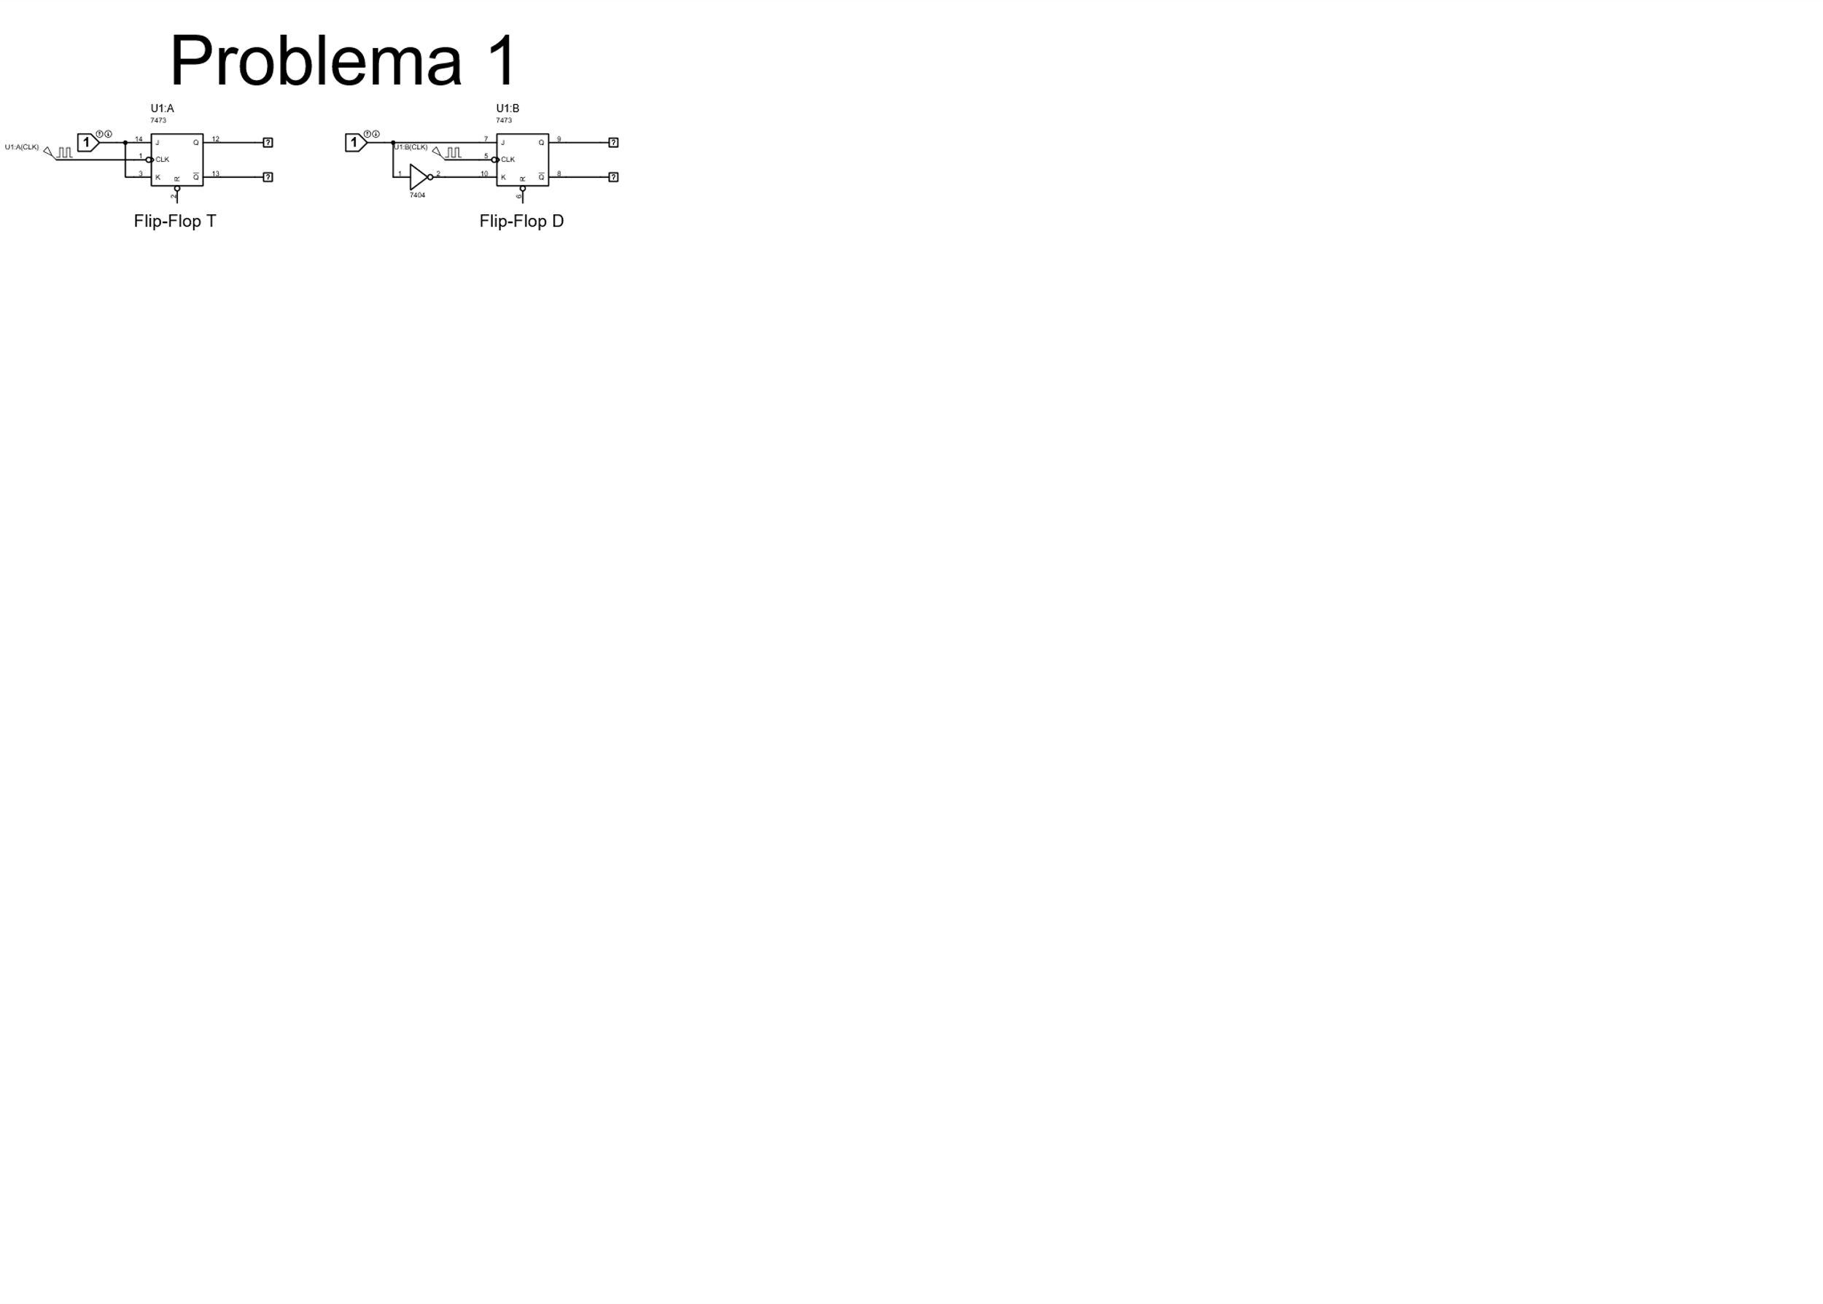

# PROBLEMA 2

## Black-Box

X

Y

Pullsos

QA

QB

Contador Ascendente cíclico de tres bits

## Diagrama de estados

## Descendente [3-0]

## Orden [2,0,1,3]

## Orden [3,1,2,0]

## Ascendente [0-3]

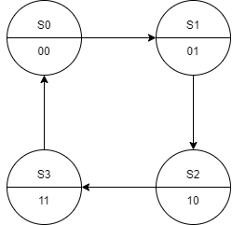

## No. Y tipo de Flip-Flops

$2^{n}=No estados=4$

$n=2 por lo tanto necesitamos 2 Flip-Flops JK para cada condición$

## Asignación de valores a los estados

|  |  |  |
| --- | --- | --- |
| Estado | QB | QA |
| S0 | 0 | 0 |
| S1 | 0 | 1 |
| S2 | 1 | 0 |
| S3 | 1 | 1 |

## Tabla de excitación

## Descendente [3-0]

|  |  |  |  |  |  |  |  |  |
| --- | --- | --- | --- | --- | --- | --- | --- | --- |
|  | Estado presente | | Estado siguiente | | B | | A | |
| J | **QB** | **QA** | **QB+1** | **QA+1** | **JB** | **KB** | **JA** | **KA** |
| 0 | 0 | 0 | 1 | 1 | 1 | X | 1 | X |
| 1 | 0 | 1 | 0 | 0 | 0 | X | X | 1 |
| 2 | 1 | 0 | 0 | 1 | X | 1 | 1 | X |
| 3 | 1 | 1 | 1 | 0 | X | 0 | X | 1 |

## Orden [2,0,1,3]

|  |  |  |  |  |  |  |  |  |
| --- | --- | --- | --- | --- | --- | --- | --- | --- |
|  | Estado presente | | Estado siguiente | | B | | A | |
| J | **QB** | **QA** | **QB+1** | **QA+1** | **JB** | **KB** | **JA** | **KA** |
| 0 | 0 | 0 | 0 | 1 | 0 | X | 1 | X |
| 1 | 0 | 1 | 1 | 1 | 1 | X | X | 0 |
| 2 | 1 | 0 | 0 | 0 | X | 1 | 0 | X |
| 3 | 1 | 1 | 1 | 0 | X | 0 | X | 1 |

## Orden [3,1,2,0]

|  |  |  |  |  |  |  |  |  |
| --- | --- | --- | --- | --- | --- | --- | --- | --- |
|  | Estado presente | | Estado siguiente | | B | | A | |
| J | **QB** | **QA** | **QB+1** | **QA+1** | **JB** | **KB** | **JA** | **KA** |
| 0 | 0 | 0 | 1 | 1 | 1 | X | 1 | X |
| 1 | 0 | 1 | 1 | 0 | 1 | X | X | 1 |
| 2 | 1 | 0 | 0 | 0 | X | 1 | 0 | X |
| 3 | 1 | 1 | 0 | 1 | X | 1 | X | 0 |

## Ascendente [0-3]

|  |  |  |  |  |  |  |  |  |
| --- | --- | --- | --- | --- | --- | --- | --- | --- |
|  | Estado presente | | Estado siguiente | | B | | A | |
| J | **QB** | **QA** | **QB+1** | **QA+1** | **JB** | **KB** | **JA** | **KA** |
| 0 | 0 | 0 | 0 | 1 | 0 | X | 1 | X |
| 1 | 0 | 1 | 1 | 0 | 1 | X | X | 1 |
| 2 | 1 | 0 | 1 | 1 | X | 0 | 1 | X |
| 3 | 1 | 1 | 0 | 0 | X | 1 | X | 1 |

## Articulación Algebraica

## Descendente [3-0]

* JB = ¬QA

|  |  |  |
| --- | --- | --- |
| QB\QA | 0 | 1 |
| 0 | 1 | 0 |
| 1 | X | X |

* KB = ¬QA

|  |  |  |
| --- | --- | --- |
| QB\QA | 0 | 1 |
| 0 | X | X |
| 1 | 1 | 0 |

* JA = 1

|  |  |  |
| --- | --- | --- |
| QB\QA | 0 | 1 |
| 0 | 1 | X |
| 1 | 1 | X |

* KA = 1

|  |  |  |
| --- | --- | --- |
| QB\QA | 0 | 1 |
| 0 | X | 1 |
| 1 | X | 1 |

## Orden [2,0,1,3]

* JB = QA

|  |  |  |
| --- | --- | --- |
| QB\QA | 0 | 1 |
| 0 | 0 | 1 |
| 1 | X | X |

* KB = ¬QA

|  |  |  |
| --- | --- | --- |
| QB\QA | 0 | 1 |
| 0 | X | X |
| 1 | 1 | 0 |

* JA = ¬QB

|  |  |  |
| --- | --- | --- |
| QB\QA | 0 | 1 |
| 0 | 1 | X |
| 1 | 0 | X |

* KA = QB

|  |  |  |
| --- | --- | --- |
| QB\QA | 0 | 1 |
| 0 | X | 0 |
| 1 | X | 1 |

## Orden [3,1,2,0]

* JB = 1

|  |  |  |
| --- | --- | --- |
| QB\QA | 0 | 1 |
| 0 | 1 | 1 |
| 1 | X | X |

* KB = 1

|  |  |  |
| --- | --- | --- |
| QB\QA | 0 | 1 |
| 0 | X | X |
| 1 | 1 | 1 |

* JA = ¬QB

|  |  |  |
| --- | --- | --- |
| QB\QA | 0 | 1 |
| 0 | 1 | X |
| 1 | 0 | X |

* KA = ¬QB

|  |  |  |
| --- | --- | --- |
| QB\QA | 0 | 1 |
| 0 | X | 1 |
| 1 | X | 0 |

## Ascendente [0-3]

* JB = QA

|  |  |  |
| --- | --- | --- |
| QB\QA | 0 | 1 |
| 0 | 0 | 1 |
| 1 | X | X |

* KB = QA

|  |  |  |
| --- | --- | --- |
| QB\QA | 0 | 1 |
| 0 | X | X |
| 1 | 0 | 1 |

* JA = 1

|  |  |  |
| --- | --- | --- |
| QB\QA | 0 | 1 |
| 0 | 1 | X |
| 1 | 1 | X |

* KA = 1

|  |  |  |
| --- | --- | --- |
| QB\QA | 0 | 1 |
| 0 | X | 1 |
| 1 | X | 1 |

## Diagrama Digital

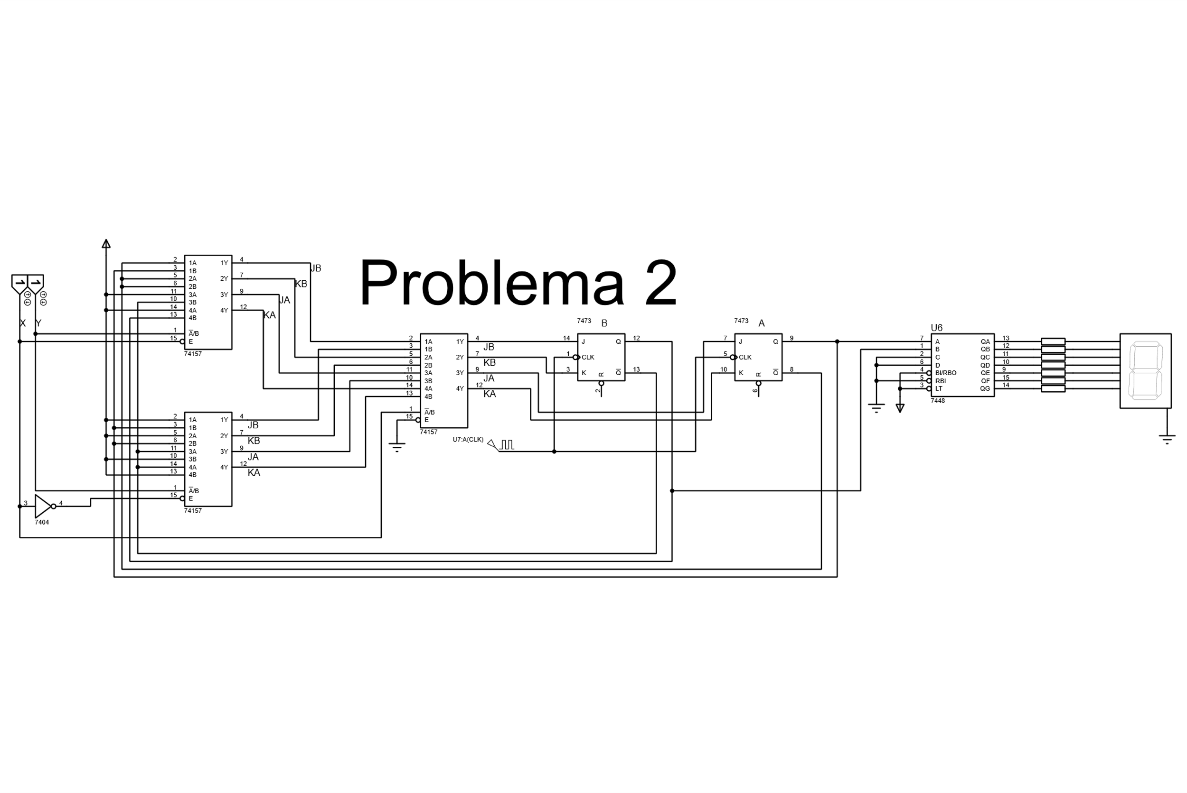

# PROBLEMA 3

Se utilizaron 3 multiplexores 74157 para verificar la entrad XY y así mandar realizar la función correspondiente, para realizar el desplazamiento hacia la izquierda se conecta la salida del ultimo FF a la entrada de su siguiente izquierdo y así sucesivamente hasta llegar al primero y en la entrada del último se coloca el bit a correr, en el desplazamiento derecho se realiza lo contrario al desplazamiento izquierdo conectando la salida del primer FF a la entrada del siguiente derecho, para realizar la carga paralela solo se conectan las entradas a su correspondiente FF.

## Diagrama Digital

